|  |  |
| --- | --- |
| **CS335 – Assignment 3**  **User Interface Design**  ***MusicSpace system***  **Group work**  **Due date: Tuesday 19th April 2016, 6pm** | |
| **Student No: 14472302**  **Student Name: Nemanja Petkovic** | **Student No:14385046**  **Student Name: Conor O’ Keeffe** |

**(Replace StudentName1 and StudentName2 of the filename with your names and check the readability of the file after submission)**

1. **User Management component**

**1.1 Screens**

**Home page:**

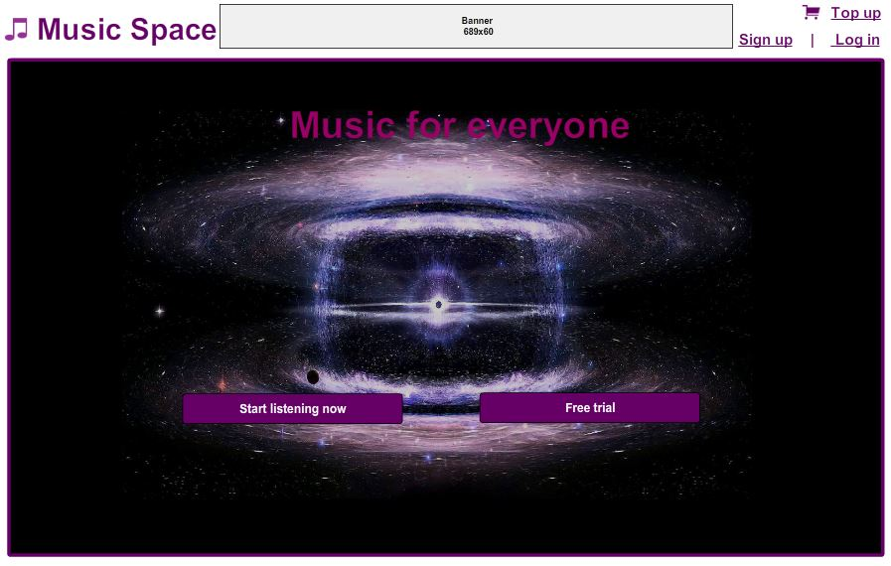

**Sign up page:**

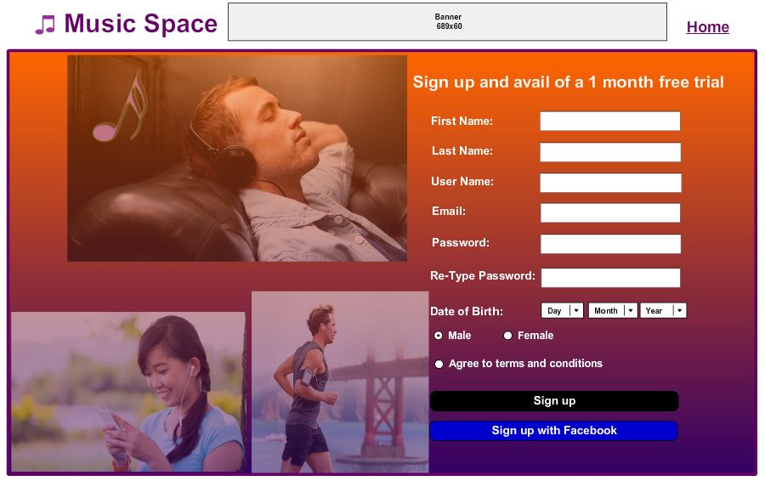

**Log in page:**

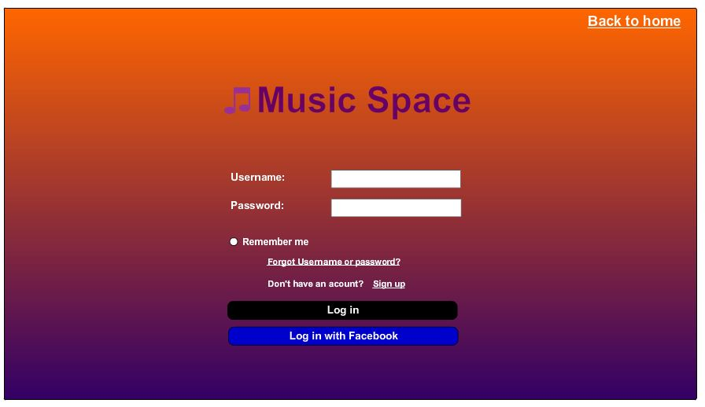

**Top up page:**

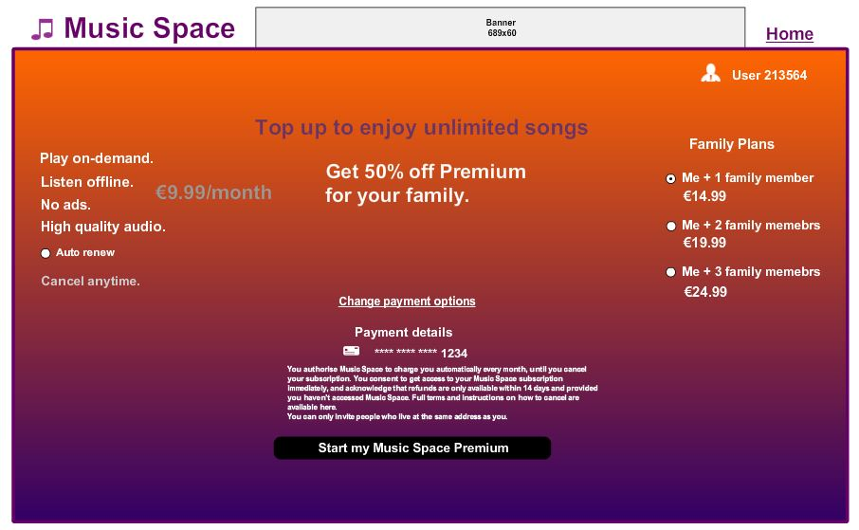

**1.2 Navigation description**

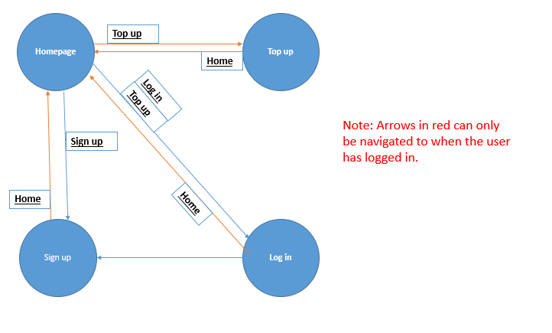

Once the Music Space software is opened the user is directed to the home page. From here a new user can click sign up to be directed to the sign up page, or click the log in to be directed to the log in page and after logging in they are brought back to the home page.

If a new user clicks top up from the homepage they first have to make a new account first so they are brought to the sign up page (note the red lines).

From the top up, sign up and log in pages the user can click the home button to go back to the home page.

1. **Streaming music component**

**2.1 Screens**

**Streaming page:**

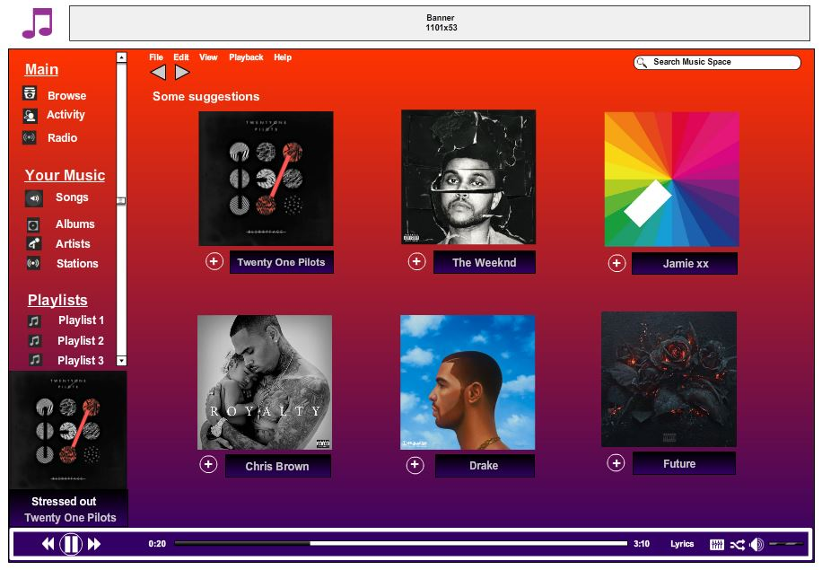

**Listening page:**

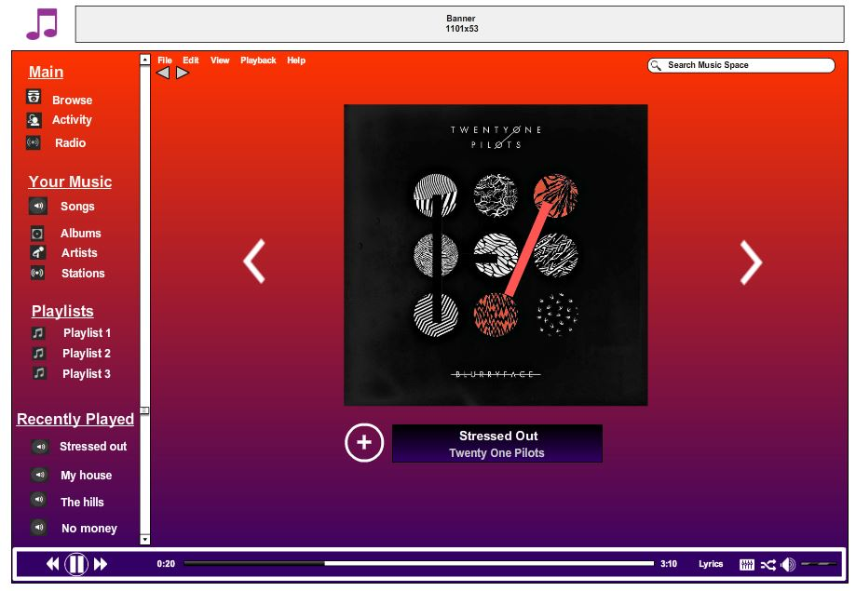

**Downloading page:**

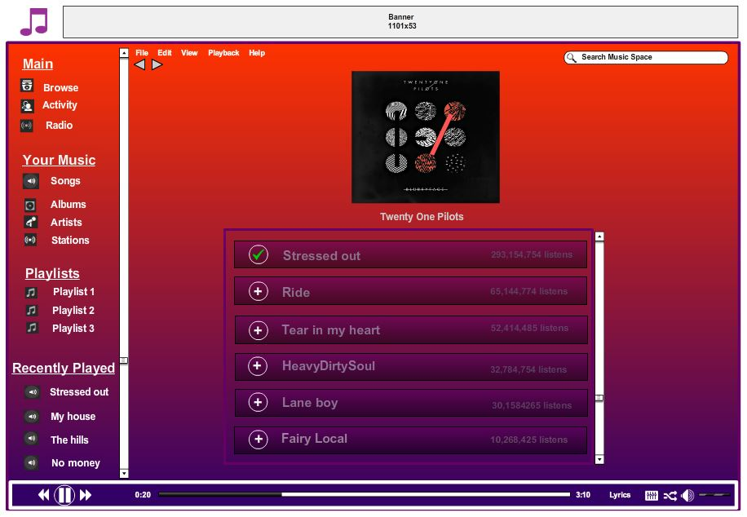

**2.2 Navigation description**

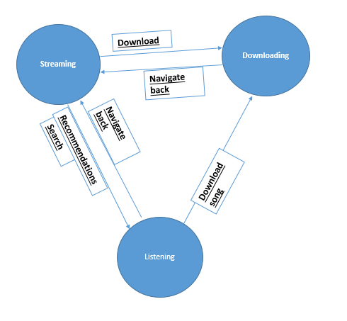

Once the user enters the streaming page the user can either search for an artist, genre or song. A list of their recommended artists and albums is also displayed on the streaming page and they can click the Download icon to add the song to their playlist or my music page. If they click on the album it brings them to the downloading page.

In the downloading page they can browse the artist’s collection and select a song to download. The search function is also possible on this page. Using the navigate back button brings the user back to the streaming page.

Finally if a user selects a song to play they are directed to the listening page where they can skip to the next or previous song and also download it. Searching is also possible on this page. The user can also use the navigate back button to go back to the streaming page.

The time bar is always displayed at the bottom of the page on every page to be a convenience to the user to easily pause, skip forward or change songs. They can also turn up or down the volume, get the lyrics, enable the shuffle feature and alter the equalizer.